**SPEED CONTROL SYSTEM**

* To control the speed of the vehicle without any disturbance to the driver

**Team Name: Fearless Group**

**Team Member**

**Deeban N**

**Dharun Kumar KSP**

**Jegatha S**

**Punitha N**

**Speed Control System**

**ABSTRACT**

Most of the road accidents occur due to over speeding in highways and also in crowd areas, and also while crossing the road when the signal is in red. Vehicles crossing the red signal become the major problem in our roads. Due to increasing number of driving vehicles on the road, monitoring traffic violation manually by the traffic police has become difficult and too complicated. This reckless driving of vehicles causes several accidents and even they are dead due to this violation. The rate of road accident is going on increasing and has become a major area of concern. To reduce the rate of road accident we propose a system called ‘Speed Control System’ which controls the speed of vehicle automatically in any critical zone, without major inconvenience to driver. Here, we introduce a model based on Radio Frequency Identification (RFID) technology. One Radio Frequency Identification reader inside the vehicle reads the RFID tag placed either at speed limit signboard or at traffic light. A controlling module (Microcontroller) in the vehicle takes the decision and control the speed according to the given speed limit.

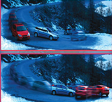

**SPEED CONTROL SYSTEM**

**Overview and Description:**

In today’s world, in each and every home, at least they have one vehicle to drive. Intelligent instruments are used in every part of our lives. They will perform one of the most complicated tasks that a person does in a day, that of driving a vehicle. As the days of man driving are getting extremely numbered, there causes traffic jams and most importantly accidents due to uncontrolled speed while driving the vehicle. In September 2001, Mr Willie D. Jones in the IEEE SPECTRUM magazine told that, a person dies in an accident for each and every second. Automation of the driving and speed control of two-wheelers is one of the most vital needs of the hour. Considering the hazards of driving speed and their effect on two-wheeler, our ‘speed control system’ is more helpful to prevent from those hazards. Our main goal is to control driving speed in the vehicle and enjoy the rides without any accidents.

Every year, we find more and more road accidents due to increased traffic on the roads and uncontrolled speed of the vehicle & while crossing the signals. Now-a-days people are driving very fast and so accidents are occurring frequently. We lost our valuable life by making small mistake while driving fast to school zone, hills area, highways and in traffics. So our speed control system can be used to avoid such kind of accidents and to alert the drivers and to control their vehicle speed. The project is composed of two separate units: zone transmitter unit and receiver unit. Once the information is received from the zones, the vehicle’s speed control unit automatically reduce the speed according to the zone. The speed of vehicles is controlled by the RF (Radio Frequency) communication method. Transmitter presents in speed restriction zones while Radio Frequency receiver present in the vehicle. When a vehicle enters this zone, then these transmitters will send continuous coded signal to those vehicle. The receiver in vehicle will receive those signals and then the micro controller. This microcontroller automatically alerts the driver to reduce the vehicle’s speed according to the zones, then it wait for few seconds and if they not reduced the speed then vehicle’s speed control unit reduces the speed automatically.

Transmits Signal to the vehicle 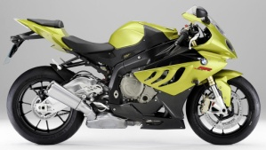

Receive signal

REDUCE THE VEHICLE’S SPEED

**Main Motto:**

Reduce the vehicle’s speed according to the areas.

Maintain the Traffic rules and regulations.

This system will be very helpful to the passengers to cross the road safely and to avoid danger from the high speed vehicles.

This system helps to avoiding the rash driving of the drivers.

No one will lose their valuable life in the accidents.

**ARCHITECTURE**

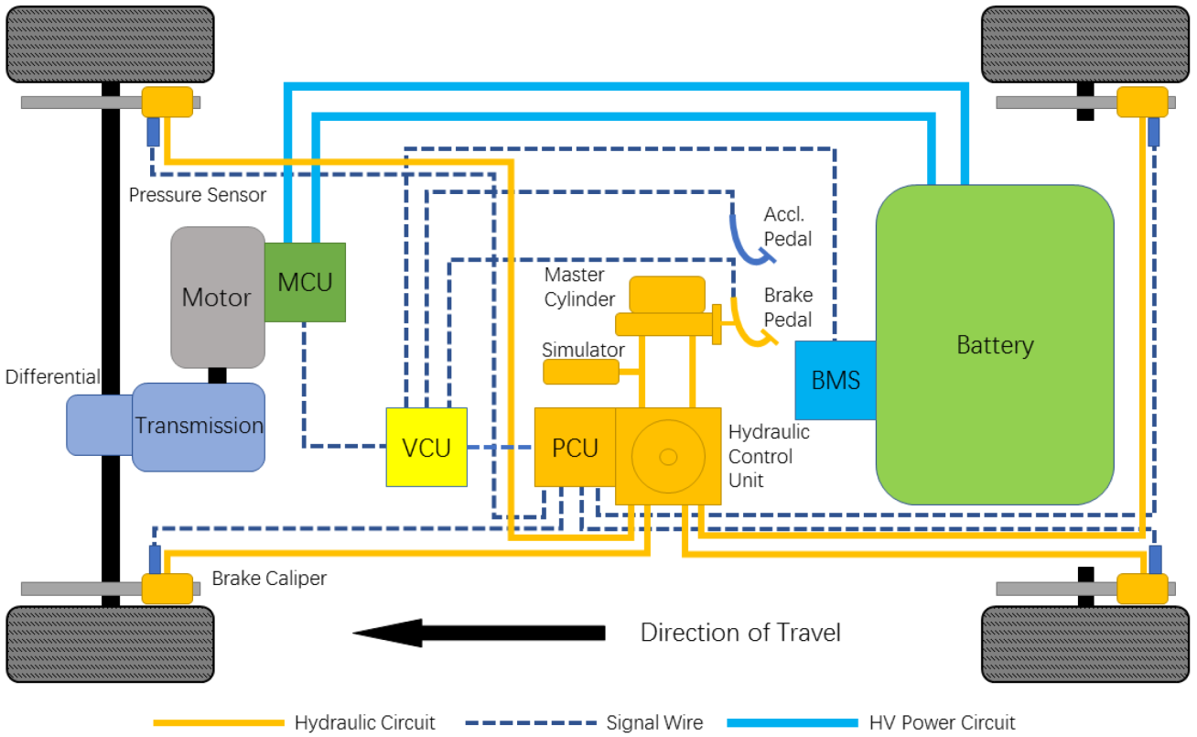

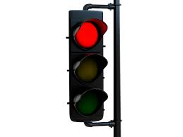   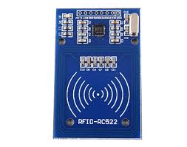

**Activates RFID sensors**

**Signal is transmitted**

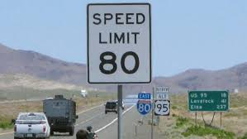 

**Signal is received**

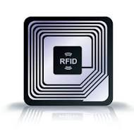

**For speed limit 80 For Red signal**

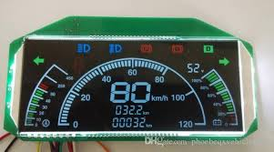 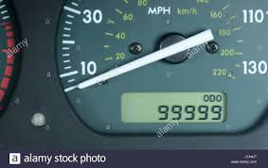

**80 kmph 0 - 5 kmph**

**TOOLS AND ENVIRONMENT**

Here we are placing a Radio Frequency Identification reader sensor inside the vehicle to receive the signal from the RFID tag which is placed in the speed limit board, in sign board and in traffic signal that transmits the signal to the vehicle. This sensor (RFID sensor) will mainly focus on the speed of the vehicle (Speedometer) and control the speed using the microcontroller (Controller Circuit). Suppose if there is any severe damage to any vehicle with the help of GPS (Tracking circuit), we can track the vehicle.

When the vehicle passes the boards, where RFID tag is placed, the signal from RFID tag received to the RFID receiver in the vehicle and then to the Microcontroller which will reduce the speed of the vehicle according to the signal received from the board.

In our speed control system we are using RF communication, using this we can automatically reduce the speed in the wanted zones. The range of RF about 10 KHZ to 300 GHZ frequency for wireless communication.

**TRANSMITTER:**

Sign Board or Signal board or speed limit board

Power Supply

RFID TAG

Vehicle Passes

Activates the RFID tag sensor to transmit the signal waves / frequency about 10 KKZ – 300 GHZ

**RECEIVER:**

RECEIVER receives signal from transmitter, using RFID tag sensor in the Micro Controller in the vehicle

Micro Controller

(Controller Circuit)

Power Supply about 5V

Activates Breaking system and reduce the speed of the vehicles slowly

**STIMULATION**

Sensors present in various place stimulates the signal if and only if any vehicle passes through the sensors. Then the signal transmitted by RFID reader is transmitted to the RFID tag receiver which is placed in the vehicle, then it goes to the microcontroller in the vehicle, there it stimulates the breaking system to reduce the speed of the vehicle using the microcontroller. This RF communicator is inserted in the every place i.e., in sign board like Go Slow, School Zone, Hair pin Bend and in speed limit board and also in traffic signal board. It will control any kind of vehicle that passes through the sensor.

Input signal i.e. vehicle passes through RFID sensor

Encodes the signal in the micro controller circuit

Transmits the en coded Signal

Encoded Signal is decoded in the microcontroller circuit

Receiver, receives the signal from the transmitter in the vehicle using RFID tag sensor

Reduces the speed of the vehicle if it is activated in the traffic signal zone then speed reduces to 0 KMPH on Red signal otherwise reduces the speed of the vehicle according to the wanted Zone.

**REFERENCE**

<https://www.researchgate.net/publication/316663781_Review_of_Automatic_Speed_Control_of_Vehicle_using_RFID_Technology>